**­**

**PRODUCT SPECIFICATION – SECTION 095 10 – ACOUSTICAL CEILING PANELS  
Frameworkstm 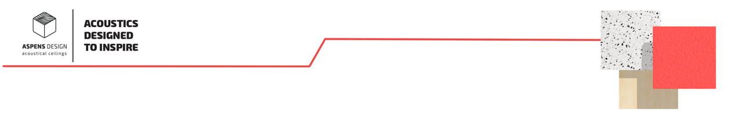: [23¾” x 23¾”] [23¾” x 47¾”] x [1.50”] mineral fiber acoustical open cell coffer ceiling panels with insert on top of coffer as indicated and specified on drawings**

**2.1 MANUFACTURER**

1. Bluffview Development Group LLC: Aspens Design Legacy
2. Address: La Crosse, WI 54603
3. Phone Number: +1 (608) 518 6085
4. Website:[www.interiorsystems.com](http://www.interiorsystems.com)
5. Email: [customer](mailto:ceilings@interiorsystems.com)care@bluffviewgroup.com

**2.2 ACOUSTIC CEILING UNITS**

A. Acoustical Ceiling Panel (ACP) - [Type ACP-1]

* + 1. Name: Frameworks Open Cell Coffer Mineral Fiber Ceiling Panels
    2. Physical Characteristics
       1. Pattern: [F22, F24, DC-Circle, DC-Square]
       2. Size:
          1. 23.75’’x 23.75’’ [F11, F12, F22, DC-Circle, DC-Square]
          2. 23.75’’x 47.75’’ [F24]
    3. Thickness: 0.750’’- Frame Only, 1.500’’ Frame w/insert [ F22, F24, DC-Circle, DC-Square]
    4. Edge: F22, F24: [Reveal 9/16’’, Reveal 15/16’’], DC-Circle, DC-Square: [Reveal 9/16’’, Reveal 15/16’’, Square]
    5. Inserts:
       - 1. F22 [Mineral Fiber to match texture color]
         2. DC-Circle, DC-Square: Mineral Fiber to match texture color
    6. Finished Surface: Lightly Textured lay-in panels
    7. Finished Surface Color: [White, Standard Flat (Manila, Beige Breeze, Haze, Platinum), Metallic, Accented Metallic, Custom Flat Latex Color #]
    8. Core Composition: Wet-felted mineral fiber
    9. Recycled Content: 68%
    10. Performance Criteria
        - 1. Noise Reduction Coefficient (NRC): 0.50
          2. Ceiling Attenuation Class (CAC): 35
          3. Flame Spread Classification: Class A Non-combustible

Flame Spread 25

Smoked Developed 50

